DEP Environmental Education Curricula
Lesson Plan
GRADE/LEVEL: Middle School
LESSON TITLE: Renewable Energy

Next Generation Science Standards
MS-ETS1-1 | MS-ETS1-1 | Define the criteria and constraints of a design problem with sufficient precision to ensure a successful solution, taking into account relevant scientific principles and potential impacts on people and the natural environment that may limit possible solutions.
 | Science and Engineering Practices | Define a design problem that can be solved through the development of an object, tool, process or system and includes multiple criteria and constraints, including scientific knowledge that may limit possible solutions.
 | Disciplinary Core Ideas | The more precisely a design task’s criteria and constraints can be defined, the more likely it is that the designed solution will be successful. Specification of constraints includes consideration of scientific principles and other relevant knowledge that are likely to limit possible solutions.
 | Crosscutting Concepts | All human activity draws on natural resources and has both short and long-term consequences, positive as well as negative, for the health of people and the natural environment.  The uses of technologies and limitations on their use are driven by individual or societal needs, desires, and values; by the findings of scientific research; and by differences in such factors as climate, natural resources, and economic conditions.
Objectives
Objective 1: Students will state the difference between fossil and renewable fuels.
Objective 2: Students will review the different advantages and disadvantages of several renewable energy types.
Objective 3: Students will be able to discuss the societal contributions and limitations of using renewable energy versus fossil fuel based energy.
Objective 4: Students will adopt a classroom action plan to conserve energy.

Vocabulary
 | Biomass | Organic matter used as a fuel, especially in a power station for the generation of electricity.
 | Energy Sources | Energy sources are divided into two categories: renewable and non-renewable. Renewable and non-renewable energy sources can be used as primary energy sources to produce useful energy such as heat or used to produce secondary energy sources such as electricity. (Source EIA).
 | Energy Technologies | Types of energy technology include solar, geothermal, wind, tidal, hydro, bioenergy/biomass/anaerobic digestions, waste-to-energy, nuclear, and fossil fuels.
 | Estuaries | The points on the coast where rivers flow into the sea and vice versa.
 | Externalities  “disadvantages” | A secondary or unintended consequence – pollution and other externalities of manufacturing) Source Merriam Webster dictionary).
 | Fossil Fuels | Fossil fuel is a general term for buried combustible geologic deposits of organic materials.
 | Global Warming | A gradual increase in the overall temperature of the earth's atmosphere generally attributed to the greenhouse effect caused by increased levels of carbon dioxide, chlorofluorocarbons, and other pollutants.
 | Greenhouse Gas | A gas that contributes to the greenhouse effect by absorbing infrared radiation, e.g., carbon dioxide and chlorofluorocarbons.
 | Kinetic Energy | Energy that a body possesses by virtue of being in motion.
 | Life-Cycle | A series of stages through which something (such as an individual, culture, or manufactured product) passes during its lifetime. (Source Merriam-Webster dictionary)
 | Nacelle | A streamlined housing.
 | Non-renewable energy | Non-renewable (an energy source that cannot be easily replenished. (Source EIA)
 | Renewable Energy | Renewable energy is energy that is collected from resources that are naturally replenished on a human timescale, such as sunlight, wind, rain, tides, waves, and geothermal heat. (Source EIA)
 | Safeguards | A precautionary measure, stipulation, or device/ a technical contrivance to prevent accident (Source Merriam Webster)
Background
Teacher Version  Selected Materials from …  Renewable Energy |  | Sources: http://www.explainthatstuff.com/renewableenergy.html and others as noted.
The world's energy resources fall into two types called non-renewable and renewable energy:
- Non-renewables are things like oil, gas, coal, and peat, formed over hundreds of millions of years when plants and sea creatures rot away, fossilize, and get buried under the ground, then squeezed and cooked by Earth's inner pressure and heat. Fossil fuels supply about 80–90 percent of the world's energy.
- Renewable energy means energy made from the wind, ocean waves, solar power, biomass (plants grown especially for energy), and so on. It's called renewable because, in theory, it will never run out. Renewable sources currently supply about 10–20 percent of the world's energy.
In theory, fossil fuels exist in limited quantities and renewable energy is limitless. That's not quite the whole story, however.
The good news is that fossil fuels are constantly being formed. But the bad news is that we're using fossil fuels much faster than they're being created. When we say fossil fuels such as oil will "run out," what we mean is that demand will outstrip supply to the point where oil will become much more expensive to use than alternative, renewable fuel sources.
Just as fossil fuel supplies aren't exactly finite, neither is renewable energy completely infinite. One way or another, virtually all forms of renewable energy ultimately come from the Sun and that massive energy source will, one day, burn itself out. Fortunately, that won't happen for a few billion years so it's reasonable enough to talk of renewable energy as being unlimited.

Solar power
For as long as the Sun blazes we'll be able to tap the light and heat it shines in our direction. We can use solar power in two very different ways: electric and thermal. Solar electric power (sometimes called active solar power) means taking sunlight and converting it to electricity in solar cells (which work electronically). Solar thermal power (sometimes called passive-solar energy or passive-solar gain) means absorbing the Sun's heat into solar hot water systems or using it to heat buildings with large glass windows.
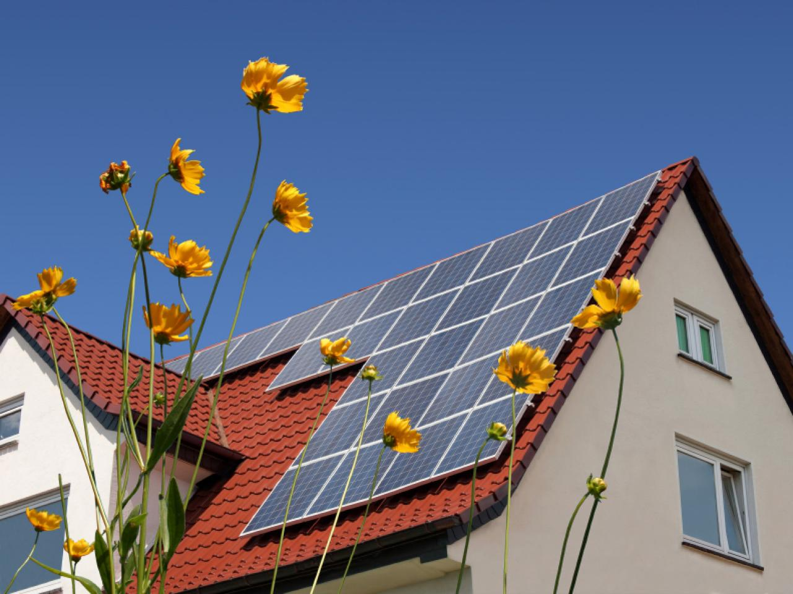
Solar Panels
http://hgtvhome.sndimg.com/content/dam/images/hgrm/fullset/2011/7/26/1/iStock-13689706_solar-panels-on-roof_s4x3.jpg.rend.hgtvcom.1280.960.suffix/1409157922480.jpeg
Advantages of using solar energy are…
- Systems do not produce air pollutants or carbon dioxide.
- Systems on buildings have minimal impact on the environment.
(Source: https://www.eia.gov/energyexplained/index.cfm?page=solar_home)
Disadvantages of solar energy are…
- The amount of sunlight that arrives at the earth's surface is not constant. The amount of sunlight varies depending on location, time of day, season of the year, and weather conditions.
- The amount of sunlight reaching a square foot of the earth's surface is relatively small, so a large surface area is necessary to absorb or collect a useful amount of energy.
(Source: https://www.eia.gov/energyexplained/index.cfm?page=solar_home)

Wind power

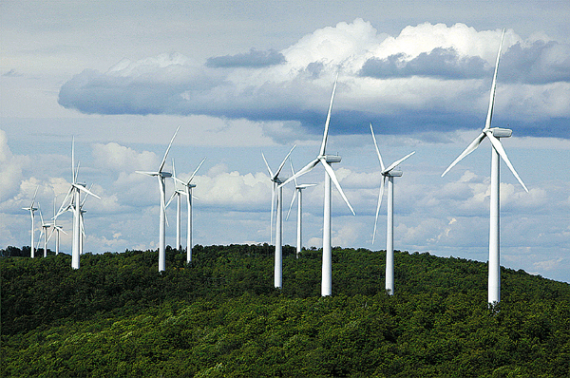

Wind Turbines

https://bdn-data.s3.amazonaws.com/uploads/2009/09/1251860949_2543.jpg
A turbine is any machine that removes kinetic energy from a moving fluid (liquid or gas) and converts it into another form. Windmills, based on this idea, have been widely used for many hundreds of years. In a modern wind turbine, huge rotating blades spin around in the wind and turn an electricity generator mounted in the nacelle (metal housing) behind the blades.
Advantages of Wind Energy…
- Clean and renewable source of power
- Cost effective
- Rapid growth of industry, large potential
(Source: https://www.conserve-energy-future.com/pros-and-cons-of-wind-energy.php)
Disadvantages of Wind Energy…
- Wind reliability
- Threat to wildlife
- Noise and visual pollution
(Source: https://www.conserve-energy-future.com/pros-and-cons-of-wind-energy.php)

Ocean power
The oceans have vast, untapped potential that we can use in three main ways: wave power, tidal barrages, and thermal power.
- Wave power uses mechanical devices that rock back and forth or bob up and down to extract the kinetic energy from moving waves and turn it into electricity.
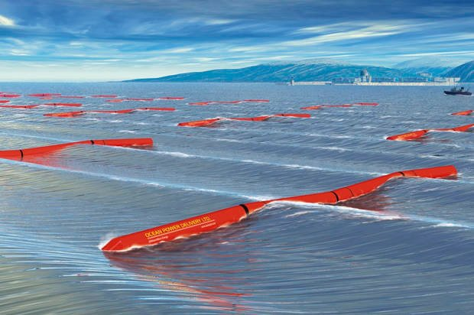
Wave Energy Conversion Device
https://media.salon.com/2016/08/wave_harvesters-620x412.jpg
- Tidal barrages are small dams built across estuaries. As tides move back and forth, they push huge amounts of water in and out of estuaries at least twice a day. A barrage with turbines built into it can capture the energy of tidal water as it flows back and forth.
- Thermal power involves harnessing the temperature difference between warm water at the surface of the oceans and cold water deeper down. In a type of thermal power called Ocean thermal energy conversion (OTEC), warmer surface water flows into the top of a giant column (perhaps 450m or 1500ft tall), mounted vertically some miles out to sea, while cooler water flows into the bottom. The hot water drives a turbine and makes electricity, before being cooled down and recycled.
Advantages of Ocean Power…
- Clean fuel source compared to fossil fuels use
- Domestic source of energy
(Source: https://en.wikipedia.org/wiki/Tidal_power)
Disadvantages of Ocean Power…
- Tidal power can have effects on marine life.
  - The turbines can accidentally kill swimming sea life with the rotating blades.
  - Some fish may no longer utilize the area if threatened with a constant rotating or noise-making object.
  - Installing a barrage may change the shoreline within the bay or estuary, affecting a large ecosystem that depends on tidal flats.
(Source: https://en.wikipedia.org/wiki/Tidal_power)

Geothermal energy
Earth may feel like a pretty cold place at times but, inside, it's a bubbling soup of molten rock. Earth's lower mantle, for example, is at temperatures of around 4500°C (8000°F). It's relatively easy to tap this geothermal (geo = Earth, thermal = heat) energy using technologies such as heat pumps, which drive cold water deep down into Earth and pipe hot water back up again.
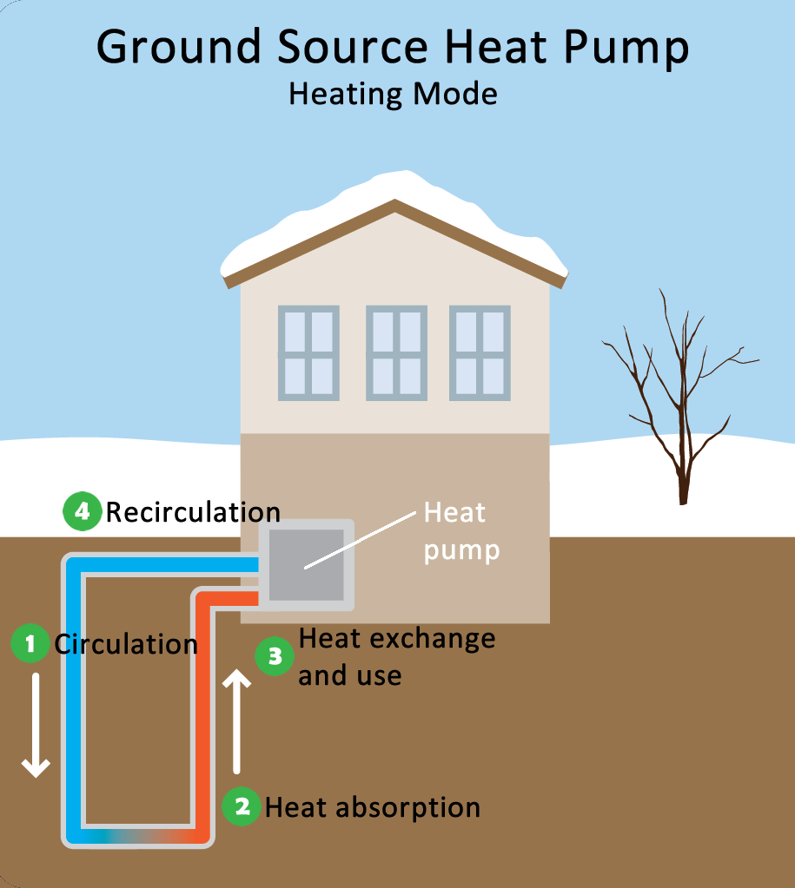
Ground Source Heat Pump
https://www.epa.gov/sites/production/files/styles/large/public/2014-11/heat-pump-heating.pn
Advantages of Geothermal Energy…
- Renewable energy
- Cleaner than burning fossil fuels
(Source: https://www.justenergy.com/blog/beneath-our-feet-an-introduction-to-geothermal-energy/)
Disadvantages of Geothermal Energy
- Cost of drilling, researching proper drilling areas
- Requires a suitable location
(Source: https://www.justenergy.com/blog/beneath-our-feet-an-introduction-to-geothermal-energy/)

Biomass
Biomass is the name given to any crop grown for making energy. Biofuels are one example. Another example includes burning animal waste in a furnace to generate electricity. Biofuels are controversial because they often take up land that could be used to grow food, but they are generally a cleaner and more efficient way of making power than using fossil fuels. Plants also absorb carbon dioxide while they're growing, a benefit to the environment.
Advantages of Biomass Energy…
- Easy to source
- Renewable in terms of time of energy generation (crop growth, etc)
- Reduces greenhouse gases
- Reduced dependence on foreign energy
(Source: https://www.conserve-energy-future.com/advantages-and-disadvantages-of-biofuels.php)
Disadvantages of Biomass Energy
- Higher cost of production (lower supply than gasoline)
- Monoculture – growing a single crop in a given area – this can deplete the efficiency of the soil for crop growth.
- Water Use
- Shortage of food
(Source: https://www.conserve-energy-future.com/advantages-and-disadvantages-of-biofuels.php)
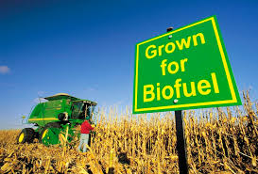
Biofuel
https://fthmb.tqn.com/WTp44xEkgdQJs0QEDk1V50y-5OQ=/768x0/filters:no_upscale()/177680720-56a2ad2a3df78cf77278b56e.jpg
Crosscutting Concepts:
- All human activity draws on natural resources and has both short and long-term consequences, positive as well as negative, for the health of people and the natural environment.
- The uses of technologies and limitations on their use are driven by individual or societal needs, desires, and values; by the findings of scientific research; and by differences in such factors as climate, natural resources, and economic conditions.
In Class Discussion of School Energy Conservation and Classroom Action List |  |  | Materials taken from Source: Summarized from  https://www.nwf.org/Eco-Schools-USA/Become-an-Eco-School/Pathways/Energy/Tips
Discuss the following options with your class.
Discuss if your school has done, or could benefit from doing, the following things… Consider how your (and their) actions to conserve energy can have both short term and long-term benefits to the environment. (climate change/resiliency contributions? Natural resources use/depletion?) What about financial benefits or hardships? What suggestions do the students have to meet these individual topics, and what challenges could stand in the way of their implementing these suggestions?

1. Work with your local energy company.
- Inquire about the possibility of obtaining energy from clean, renewable sources.
- Inquire about applicable rebate or incentive programs for using renewable energy or engaging in energy conservation.
2. Evaluate your lighting needs.
- Shut off lights when a room is not in use or when there is sufficient natural light.
- Turn exterior lights off during daylight hours and consider installing motion detectors.
- Replace incandescent light bulbs with compact fluorescents, which use 1/4 the energy and last ten times as long.
- Consider switching to LED exit signs, which use much less energy.
3. Involve students, staff and parents in energy conservation initiatives.
- Establish student patrols to check that lights are off in rooms not being used.
- Post stickers, posters and signs as reminders to turn off lights, shut down equipment and unplug items when not in use.
4. Check the building's openings.
- Keep exterior doors closed as much as possible. Close classroom doors to help retain heat.
- Place caulking and weather-stripping around doors and windows
5. Evaluate the energy efficiency of your school cafeteria.
- Review the energy rating of kitchen appliances. When purchasing new appliances, choose Energy Star models.
- Wash only full loads in the dishwashers.
- Reduce hot water temperatures throughout the school, and use a booster in the kitchen if necessary.
- Consider insulating the hot water heater and hot water pipes.
6. Make efficient use of your heating and air-conditioning systems.
- Close windows and curtains at the end of the day, and utilize curtains to either keep heat in or sun out.
- Clear space around wall and floor vents of obstructions.
- Use programmable thermostats to adjust temperatures in the evening and on weekends.
7. Pay close attention to how outlets are utilized.
- Unplug items that are not in use. Electronics consume as much as 75 percent of their total energy when turned off.
- Consider using power strips to turn off multiple items with one flip of the switch.
8. Reduce the amount of energy used by electronics and office equipment.
- Turn computers off at the end of the day. Arrange for computers to go into sleep mode when not in use, and avoid installing screen savers.
- When buying new equipment, choose Energy Star models.
9. Consider generating your own electricity on-site.
- Find out if it's possible to place solar panels on the school.
- Research wind power. Look into the new, smaller wind turbines that can be attached to building structures.
- Does the town allow/support renewable energy equipment installation? (Building Codes, tax breaks, etc.)
Use the template at the end of this lesson plan to make classroom action lists for energy conservation. Have the students make action lists for all classrooms (and offices) at the school that would like to participate. To promote success of this program consider creating a “green team” for your school to support your program. Engaging interested students in school programs can help keep them vital and growing and reduce simply placing additional demands on teachers and staff. Many hands make light work!

Teacher Prep
 | Advanced Preparation Steps &  Duration | - Read and consider associated background material, and questions for discussion. Check with school officials if you are unclear which types of energy conservation may be in place at your school. (45 minutes)  - Review video clip (3:17 minutes)  - Review Renewable Energy PowerPoint (20 minutes)
Needed Materials
- Renewable Energy 101 – National Geographic https://www.youtube.com/watch?v=1kUE0BZtTRc
- Renewable Energy PowerPoint
- Renewable Energy Lesson Plan
- Internet Connection
 | Duration of activities | 60 minutes
 | Safety notes | N/A
Procedures for Instruction
 |  | Introduce the class to the idea of renewable energy |  | ~2 minutes
 |  | Renewable Energy, and the embedded film |  | ~25 minutes  (PowerPoint)
 |  | Energy Conservation Discussion and Class Action Plan Posters |  | ~25 minutes
Student Materials
 | Background Informational Sheet | Reading assignment prior to the lesson day.
 | Vocabulary List | Available for clarification of terminology as students read their Background Informational Sheet.

Student Background Information Sheet – Renewable Energy
The world's energy resources fall into two types called non-renewable and renewable energy:
- Non-renewables are things like oil, gas, coal, and peat, formed over hundreds of millions of years when plants and sea creatures rot away, fossilize, and get buried under the ground, then squeezed and cooked by Earth's inner pressure and heat. Fossil fuels supply about 80–90 percent of the world's energy.
- Renewable energy means energy made from the wind, ocean waves, solar power, biomass (plants grown especially for energy), and so on. It's called renewable because, in theory, it will never run out. Renewable sources currently supply about 10–20 percent of the world's energy.

Solar power
For as long as the Sun blazes we'll be able to tap the light and heat it shines in our direction. We can use solar power in two very different ways: electric and thermal. Solar electric power (sometimes called active solar power) means taking sunlight and converting it to electricity in solar cells (which work electronically). Solar thermal power (sometimes called passive-solar energy or passive-solar gain) means absorbing the Sun's heat into solar hot water systems or using it to heat buildings with large glass windows.
Solar Panels
http://hgtvhome.sndimg.com/content/dam/images/hgrm/fullset/2011/7/26/1/iStock-13689706_solar-panels-on-roof_s4x3.jpg.rend.hgtvcom.1280.960.suffix/1409157922480.jpeg
Advantages of using solar energy are…
- Systems do not produce air pollutants or carbon dioxide.
- Systems on buildings have minimal impact on the environment.
(Source: https://www.eia.gov/energyexplained/index.cfm?page=solar_home)
Disadvantages of solar energy are…
- The amount of sunlight that arrives at the earth's surface is not constant. The amount of sunlight varies depending on location, time of day, season of the year, and weather conditions.
- The amount of sunlight reaching a square foot of the earth's surface is relatively small, so a large surface area is necessary to absorb or collect a useful amount of energy.
(Source: https://www.eia.gov/energyexplained/index.cfm?page=solar_home)

Wind power

Wind Turbines

https://bdn-data.s3.amazonaws.com/uploads/2009/09/1251860949_2543.jpg
A turbine is any machine that removes kinetic energy from a moving fluid (liquid or gas) and converts it into another form. Windmills, based on this idea, have been widely used for many hundreds of years.
Advantages of Wind Energy…
- Clean and renewable source of power
- Cost effective
- Rapid growth of industry, large potential
(Source: https://www.conserve-energy-future.com/pros-and-cons-of-wind-energy.php)
Disadvantages of Wind Energy…
- Wind reliability
- Threat to wildlife
- Noise and visual pollution
(Source: https://www.conserve-energy-future.com/pros-and-cons-of-wind-energy.php)

Ocean power
The oceans have vast, untapped potential that we can use in three main ways: wave power, tidal barrages, and thermal power.
- Wave power uses mechanical devices that rock back and forth or bob up and down to extract the kinetic energy from moving waves and turn it into electricity.
Wave Energy Conversion Device
https://media.salon.com/2016/08/wave_harvesters-620x412.jpg
- Tidal barrages are small dams built across estuaries. As tides move back and forth, they push huge amounts of water in and out of estuaries at least twice a day. A barrage with turbines built into it can capture the energy of tidal water as it flows back and forth.
- Thermal power involves harnessing the temperature difference between warm water at the surface of the oceans and cold water deeper down.
Advantages of Ocean Power…
- Clean fuel source compared to fossil fuels
- Domestic source of energy
(Source: https://en.wikipedia.org/wiki/Tidal_power)
Disadvantages of Ocean Power…
- Tidal power can have effects on marine life.
  - The turbines can accidentally kill swimming sea life with the rotating blades.
  - Some fish may no longer utilize the area if threatened with a constant rotating or noise-making object.
  - Installing a barrage may change the shoreline within the bay or estuary, affecting a large ecosystem that depends on tidal flats.
(Source: https://en.wikipedia.org/wiki/Tidal_power)

Geothermal energy
Earth's lower mantle, for example, is at temperatures of around 4500°C (8000°F). It's relatively easy to tap this geothermal (geo = Earth, thermal = heat) energy using technologies such as heat pumps, which drive cold water deep down into Earth and pipe hot water back up again.
Ground Source Heat Pump
https://www.epa.gov/sites/production/files/styles/large/public/2014-11/heat-pump-heating.pn
Advantages of Geothermal Energy…
- Renewable energy
- Cleaner than burning fossil fuels
(Source: https://www.justenergy.com/blog/beneath-our-feet-an-introduction-to-geothermal-energy/)
Disadvantages of Geothermal Energy
- Cost of drilling, researching proper drilling areas
- Requires a suitable location
(Source: https://www.justenergy.com/blog/beneath-our-feet-an-introduction-to-geothermal-energy/)

Biomass
Biomass is the name given to any crop grown for making energy. Biofuels are one example. Another example includes burning animal waste in a furnace to generate electricity. Biofuels are controversial because they often take up land that could be used to grow food, but they are generally a cleaner and more efficient way of making power than using fossil fuels.
Advantages of Biomass Energy…
- Easy to source
- Renewable
- Reduces greenhouse gases
- Reduced dependence on foreign energy
(Source: https://www.conserve-energy-future.com/advantages-and-disadvantages-of-biofuels.php)
Disadvantages of Biomass Energy
- Higher cost of production (lower supply than gasoline)
- Monoculture
- Water Use
- Shortage of food
(Source: https://www.conserve-energy-future.com/advantages-and-disadvantages-of-biofuels.php)
Biofuel
https://fthmb.tqn.com/WTp44xEkgdQJs0QEDk1V50y-5OQ=/768x0/filters:no_upscale()/177680720-56a2ad2a3df78cf77278b56e.jpg
Student Vocabulary List– Renewable Energy
 | Biomass | Organic matter used as a fuel, especially in a power station for the generation of electricity.
 | Estuaries | The points on the coast where rivers flow into the sea and vice versa.
 | Fossil Fuels | Fossil fuel is a general term for buried combustible geologic deposits of organic materials, formed from decayed plants and animals that have been converted to crude oil, coal, natural gas, or heavy oils by exposure to heat and pressure in the earth's crust over hundreds of millions of years.
 | Global Warming | A gradual increase in the overall temperature of the earth's atmosphere generally attributed to the greenhouse effect caused by increased levels of carbon dioxide, chlorofluorocarbons, and other pollutants.
 | Greenhouse Gas | A gas that contributes to the greenhouse effect by absorbing infrared radiation, e.g., carbon dioxide and chlorofluorocarbons.
 | Kinetic Energy | Energy that a body possesses by virtue of being in motion.
 | Nacelle | A streamlined housing.
 | Renewable Energy | Renewable energy is energy that is collected from resources that are naturally replenished on a human timescale, such as sunlight, wind, rain, tides, waves, and geothermal heat. (Source EIA)

Check  Your Energy Use!

☐ | Shut off lights when not in use
☐ | Keep exterior & classroom doors closed to conserve heat
☐ | Keep space around wall and floor heaters clear
☐ | Unplug electrical items that are not in use
☐ | Turn off computers at the end of the day
☐ | Reduce, reuse, recycle

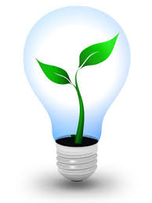
Teacher: ____________________________
Room Number: ______________________

Project Assessment
Project Title: ___________________________________________________________________________
Instructor/School/Grade: _______________________/______________________/_________________
Instructor Contact Information: ________________________________________________________________
Date assigned: _____________ Number of Students Participating ____________
The following questions are intended to help us understand your feelings regarding the presentation and materials. Your sincerity in answering these questions is appreciated. Please feel free to use the space at the end of the form for any additional comments that you may have. This form has been left in Microsoft Word format so that you may fill it in electronically. Please fill out the form completely and email your assessment to david.madore@maine.gov.
Ranking System
1 ~ Excellent / Strongly agree
2 ~ Good – Above average / Moderately agree
3 ~ Average – ok / Neutral in agree or disagree
4 ~ Poor – below average / Moderately disagree
4 ~ Very poor – not acceptable / Strongly disagree
NA / not applicable
Please continue on the second page…
1 | 2 | 3 | 4 | 5 | NA | Questions
 |  |  |  |  |  | Course Content
 |  |  |  |  |  | - Value of course content to you.
 |  |  |  |  |  | - Importance of course content given your teaching topic.
 |  |  |  |  |  | - Overall rating of course content.
 |  |  |  |  |  | - Ease of implementing materials into daily lessons.
 |  |  |  |  |  | Materials/Project
 |  |  |  |  |  | - Movie (if applicable) was easy to present.
 |  |  |  |  |  | - Student worksheet was useful and easy to follow.
 |  |  |  |  |  | - Student project stimulated thinking & conversation.
 |  |  |  |  |  | - The project put ideas across effectively.
 |  |  |  |  |  | - Teacher materials were useful and easy to follow.
 |  |  |  |  |  | - The method of material presentation encouraged students feel free to ask questions, disagree, express ideas, etc.
 |  |  |  |  |  | Self-Evaluation (Instructor)
 |  |  |  |  |  | - What was your level of knowledge concerning this topic prior to this presentation?
Please share any recommendations you feel would be helpful.

Thank you for providing your feedback!
Please email your assessment to david.madore@maine.gov.

